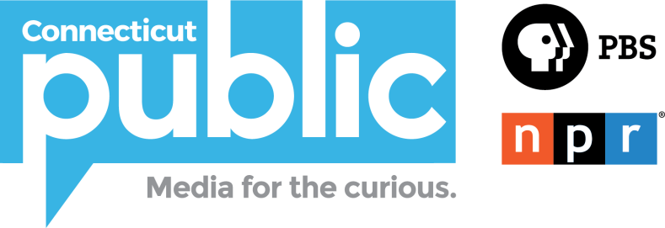
Annual Employee Giving Campaign

Why do we hold this campaign each year?
Donors and prospects want to give to organizations whose
employees and volunteers are also donors.

Many corporations and foundations ask for trustee and employee giving
rates, and consider that information when deciding on support.

Some corporations and foundations give only to organizations whose
employees and trustees are asked to make an annual donation
and results indicate a favorable giving percentage.

Employees are our best ambassadors — and your enthusiastic support
helps foster the support of prospects and donors.

Staff should support the organization they work for because they
believe in the mission and get satisfaction from seeing what is
accomplished on a day-to-day basis

Being able to say that, over time, we have achieved 100% staff giving
can only strengthen our position when asking others to give.

https://ctpublic.org/annual-employee-giving-campaign/
Employee Giving Campaign Overview
Facts:
- Prior to 2017 we had 28% of staff making a gift to CT Public
- First ever employee giving campaign was in May of 2017
- May 2017 – 58% participation raised $14,477, with $4,164 directed to Employee Giving Fund
- May 2018- 78% participation raised $15,906 with $6,678 directed to Employee Giving Fund
Why?
- Most larger (and many smaller) non-profits do employee giving campaigns
- Need to ask internally first, before we go to the public
- Donors, sponsors and foundations ask for giving percentages- answer can influence giving
- Marketing benefits- on air pledge drives, annual asks
- Can actually increase employee morale - but show reasons why giving is important- It puts our stamp of approval on our organization and our mission- it say, we believe in this enough to actually invest in it, to give of our time and personal resources.
Timeline:
- Kickoff luncheon- End of May/early June
- Commitments requested by end of fiscal year for 2019-2020 year
- Ben & Jerry’s Sundae Party Campaign Celebration- end of June
- Every year, every spring
The Ask:
- 85% participation goal
- Every gift matters, regardless of size
- United Way Campaign – designate your gift (or a portion of) to CPBN and it counts
- Designation is your choice: Unrestricted, specific area/program, Employee Giving Fund
The Benefit:
- Every staff member who makes a gift- will be made a member
- Positions us for more donor/foundation $
Employee Giving Fund:
- All $ matched 100% by CT Public
- Projects that might not otherwise be funded/budgeted
- Employee Giving Fund Committee consisting of a cross section of CT Public will vet projects and award “grants”
- Encourages creativity and support of our fellow co-workers
- In 2017 all $10,000 was awarded to the Island Next Door, a project which otherwise might not have happened without the fund
- This year’s beneficiary of $15,000 is Carol Sisco & team –Uncertainty, a 30 minute doc on student mental health
Giving Process/Supporting Materials:
- FAQ’s
- Campaign overview
- Why do we ask doc
- Payroll Deduction Form
- Employee landing pages with links to Payroll Deduction Form and FAQ’s – 10 reasons for giving, status of campaign
Needs:
- Buy in from entire Leadership Team
- CT Public to again match contributions to Employee Giving Fund
Kickoff Logistics
- Luncheon
- Carol Sisco and team to speak for a few minutes
- Uncertainty to be shown
- John Gibson to design a curiosity t-shirt thank you gift for all donors, hopefully to be created annually

Website Landing Page

Connecticut Public Annual Employee Giving Campaign
The Connecticut Public Annual Employee Giving Campaign is a unique fundraising effort that makes a difference in our organization.
Your gift is a helpful addition to the energy and commitment and talent you share with us each and every day.
Last year, we reached a 78% participation rate and are proud of the nearly $16,000 that was donated by our employees. The goal this year is 85% participation by the end of our fiscal year on June 30, 2019. Every gift matters and every gift, no matter the size, makes a difference.
Participating in the Campaign sends a profound message to the community and to potential donors and grantors that we not only work here, but also truly believe in our mission.
As a donor, you have the ability to designate your gift to a specific project, to general operating expenses, or to the new Connecticut Public Employee Giving Fund. The fund was established to subsidize your projects which might not otherwise be in our budget. Every dollar donated to this fund will be matched by Connecticut Public! To learn more, click here.
Thank you for your gift!

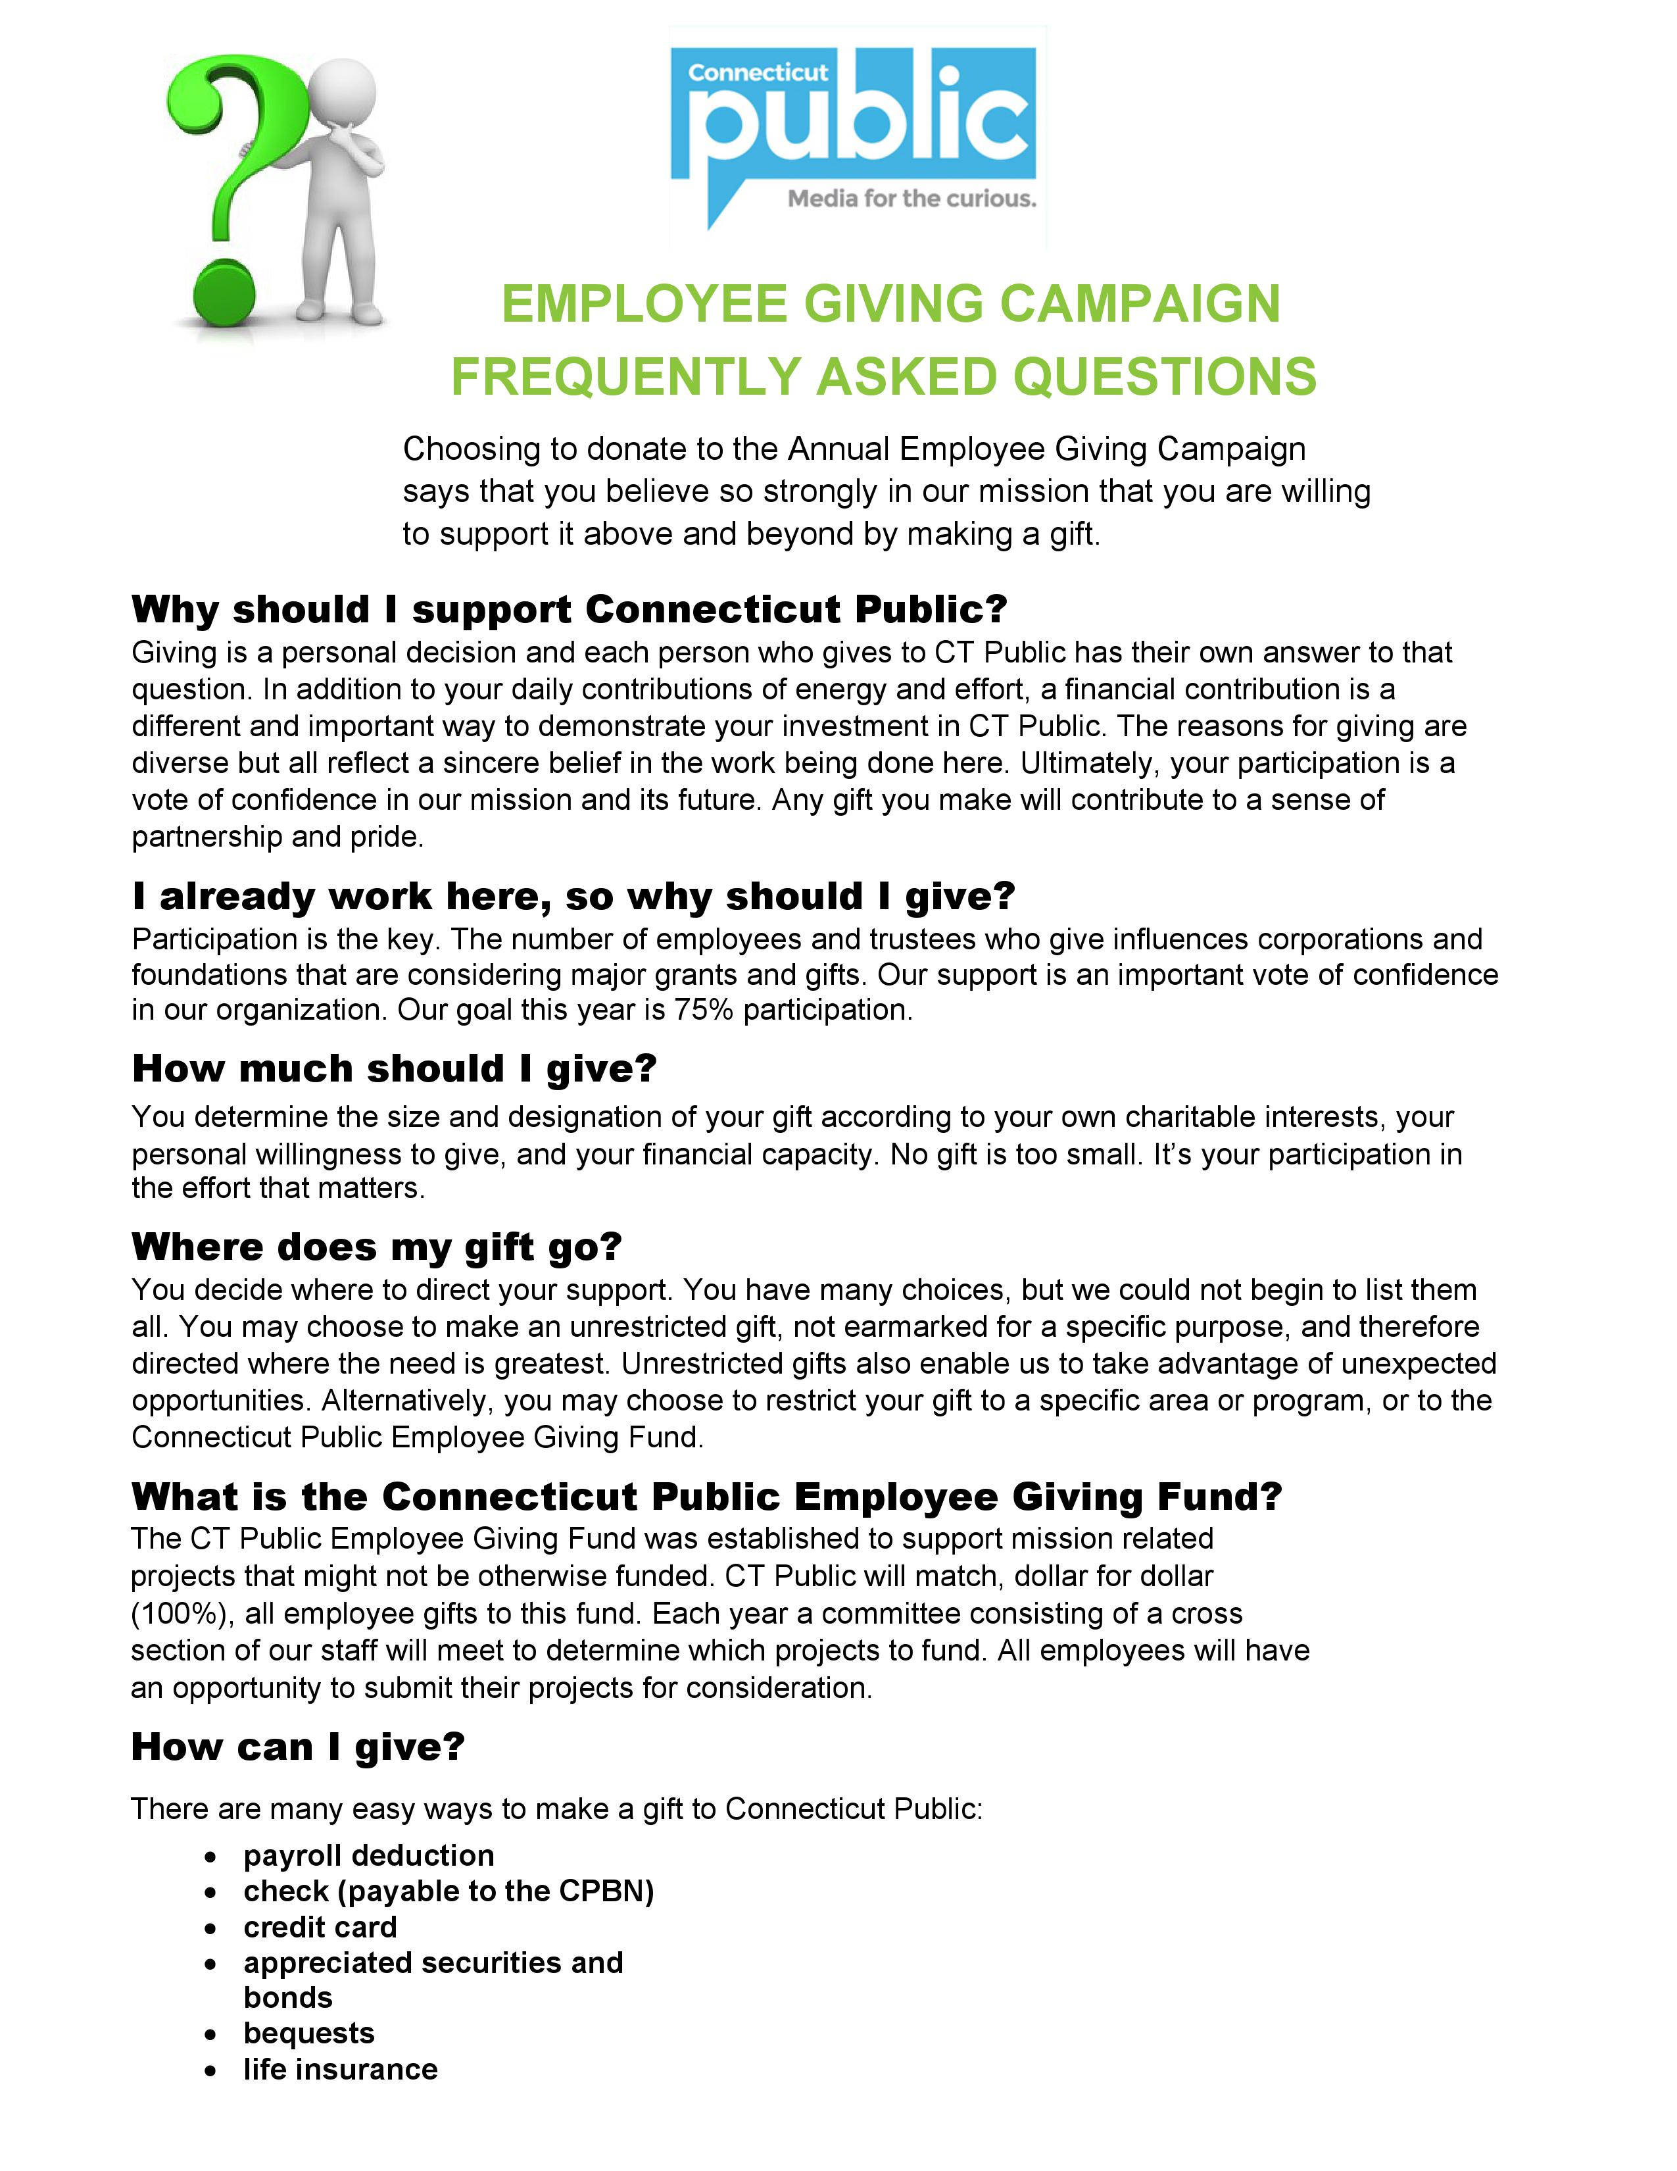
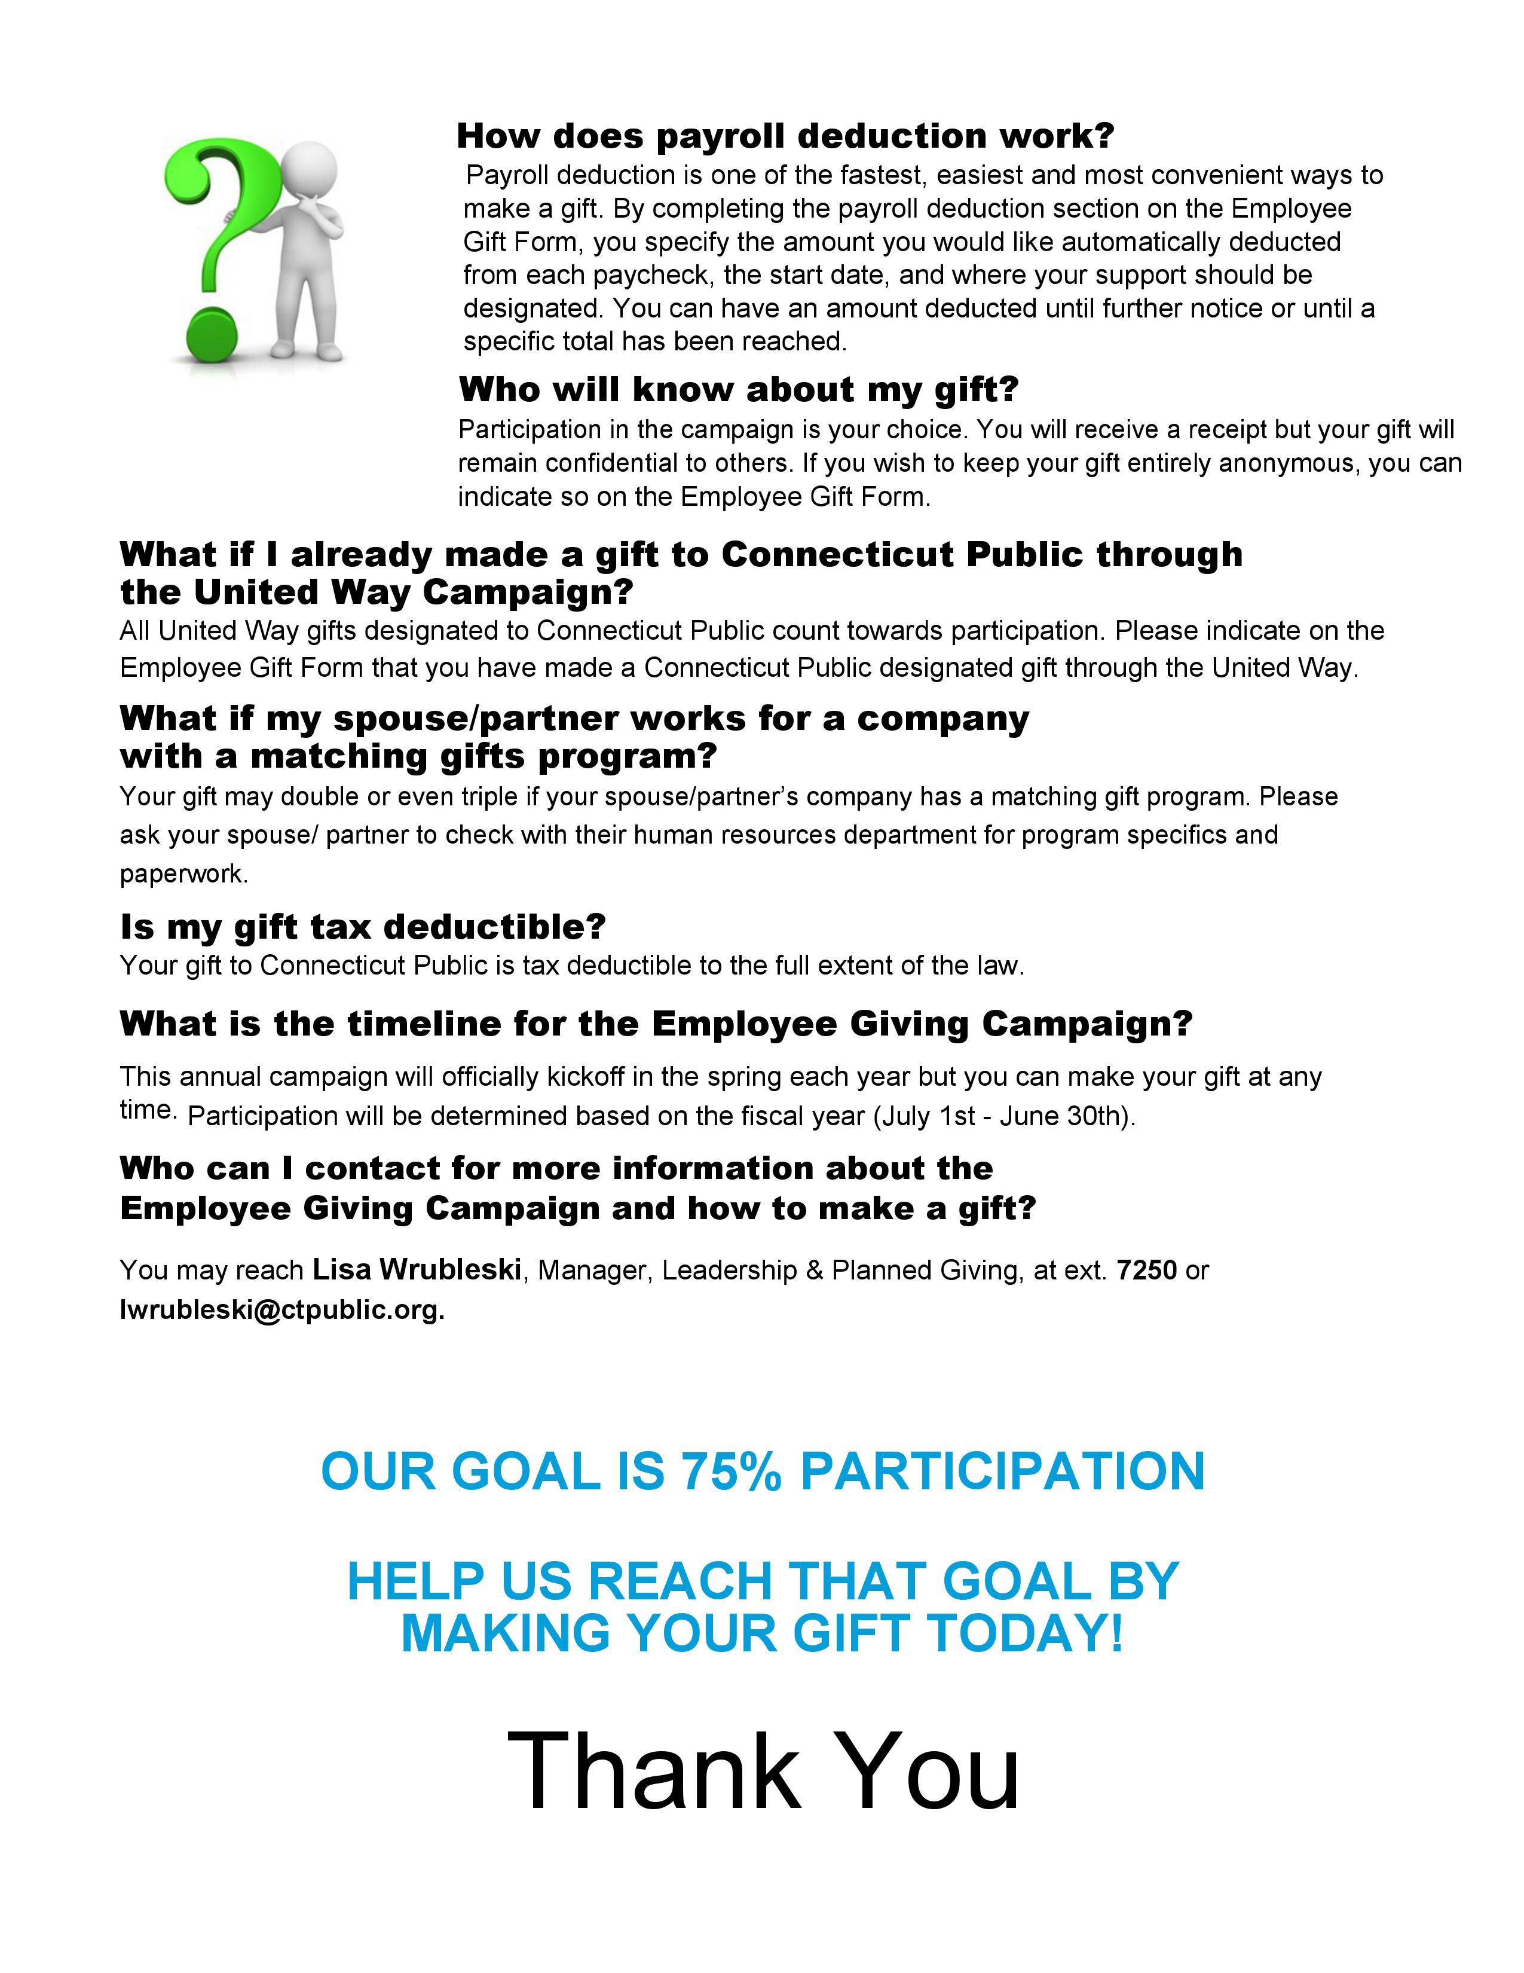
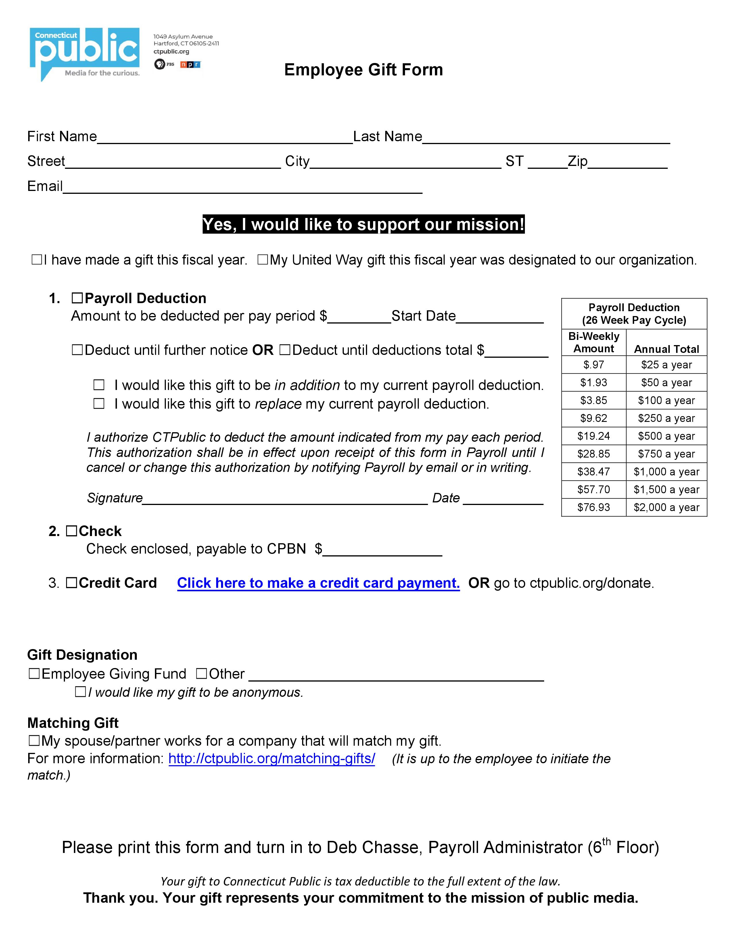
Employee Giving Fund Projects

2018 Award Winner- https://theislandnextdoor.wnpr.org/
2019 Award Winner- https://cptv.org/studentmentalhealth/

