Streaming Into the Future: An Evolving Membership Program

In 2018, PBS SoCal and KCET conducted on an in-depth research project looking at the two organization’s audiences and how they watched our content. We learned many helpful things prior to our merger, but the most amazing finding was that nearly everybody in the focus groups and surveys was streaming our content. Young, old, members, non-members, everyone did some on demand viewing and it was scattered across a variety of platforms and services. And almost nobody knew about the PBS App. This led us to make some significant changes in how we managed our membership program and it was done in a highly collaborative manner with our marketing and digital teams. Here are the key elements.

Download the App campaign

Prior to our market research, all of our streaming-related marketing went toward promoting Passport. But our research indicated that very few of even our core viewers were aware of the PBS App. Our survey also found that people who donate online stream on the PBS App or website at far higher rates than the average population. As a result, we changed our entire approach to Passport. We created pbssocal.org/app, which features step-by-step instructions on downloading the free PBS App. We promote the free PBS App page with paid digital ads, spots on the air, banners on our website, social media, and even on thank you pages for surveys, drawings and volunteer sign-up pages. We shared our campaign results at several conferences and with PBS and many stations are now doing their own, “Download the App” campaigns.

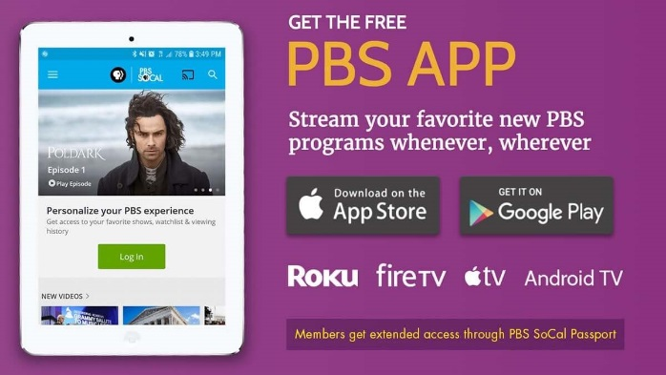

We also added links to the App on the program pages so we could move them up the streaming ladder (from streaming on browser to streaming on the App to streaming with Passport). The overall concept is that the more people we get using the App, the more people will find a show they want to watch on Passport and will support the station with a membership donation. The results has been that Passport donations soared in 2018 to over $1 million dollars and PBS SoCal Passport streams surpassed 940,000 in 2018.

Passport newsletter

Beginning in September 2017, we created a monthly Passport newsletter with a very personal voice. All of the copy and show recommendations are written in-house. The response has been incredible. Members say it is like getting show recommendations from a friend – the most powerful type of recommendation. This newsletter is a critical component of our retention strategy with Passport members. Our retention rate for new Passport-acquired members doubled in 2018, going from 43% - 86%.

Purls instead of activation codes

One of the main sticking points of Passport has been the activation process. Many members have reported being confused by activation codes. In response, we redesigned the activation process, removing activation codes entirely from the member’s experience. We send donors an email with a link that already has the activation ode embedded in it. No more clunky four-word-activation-codes. As a result, our calls about activation have plummeted.

Activation Rate

Due to our efforts to streamline the activation process and our multi-channel Passport promotion efforts, our Passport activation rate has grown by leaps and bounds.
June 2017 – 31% activated of Passport eligible
January 2018 – 52% activated of Passport eligible
June 2018 – 59% activated of Passport eligible
January 2019 – 64% activated of Passport eligible

Passport and Pledge

We have imbedded Passport throughout all seven of our solicitation streams and On-Air Fundraising is an important part of that. Pledge continues to be an excellent way to communicate with our local viewers and we use it to talk about PBS SoCal Passport.
When there is a particularly significant program on Passport, we create a special on-air campaign around it. In August, 2018, we pledged around the series finale of Poldark, prior to the new season debut and told viewers if they pledged now, they would have access to the entire new season of Poldark on the night of the debut, September 30th. This was wildly successful. We had 130 contributions in 90 minutes and raised over $10,000. 77 of the contributions were specifically for Passport and did not request another thank you gift. So, the net revenue was also very high.

Staying Agile in a Quickly Changing Media Environment

One thing we have learned this past year is that our Membership program has to stay agile and adapt to the ways that our viewers are accessing PBS content. This agile approach has proven to be very successful. Over the past five years, our membership program has doubled in size and in 2018 alone, we went from 87,000 PBS SoCal members to 105,000, a 20% increase, with most of that growth in Passport and online acquired members. * This does not include KCET members. As we move forward into a world where this is also live linear streaming of our channels, we will continue to evolve our membership messages and approaches so that local support for PBS will stay high, no matter how, or where, people view our content.

