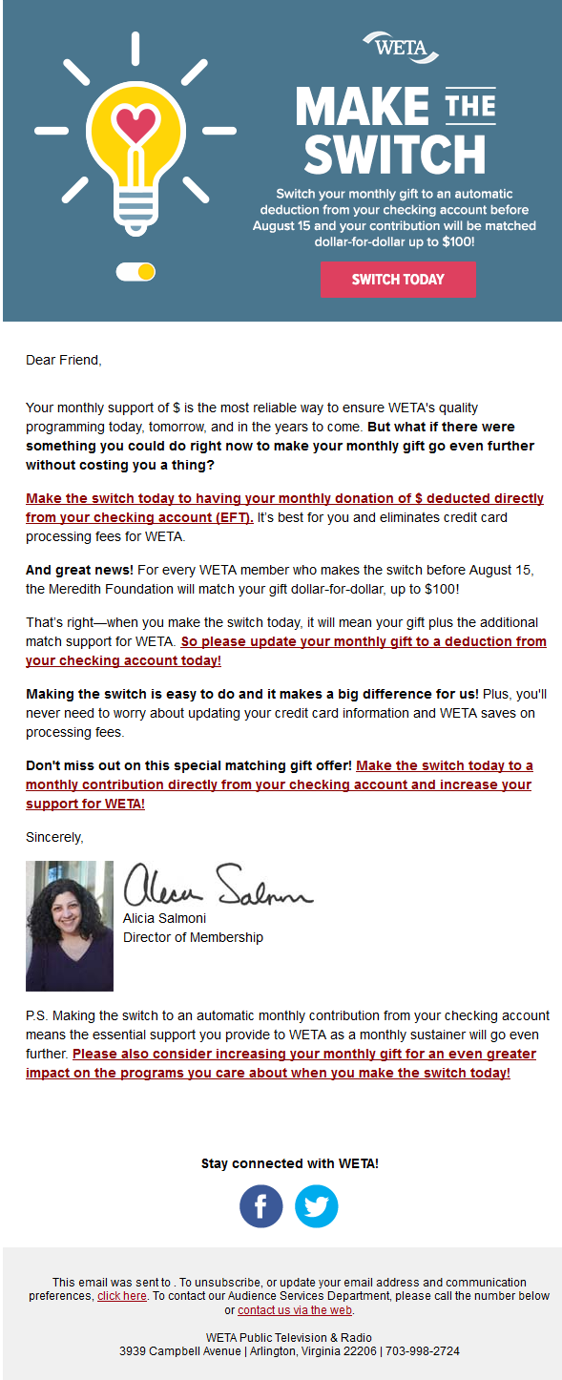

Sample Email

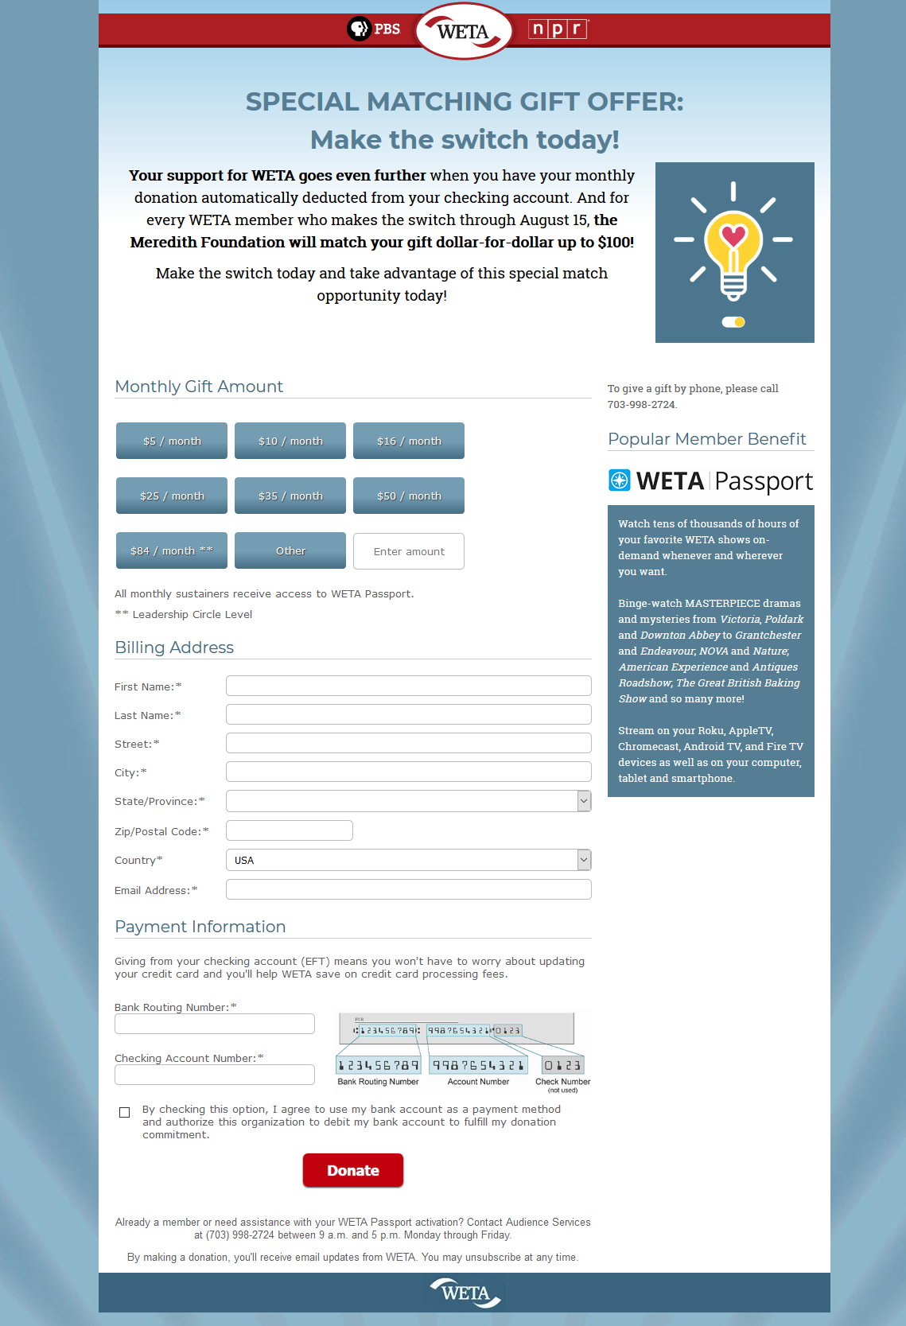

Donation Page

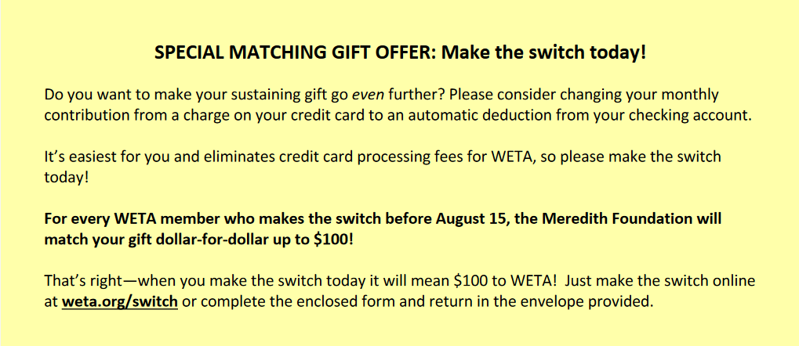

Buckslip in WETA Mail

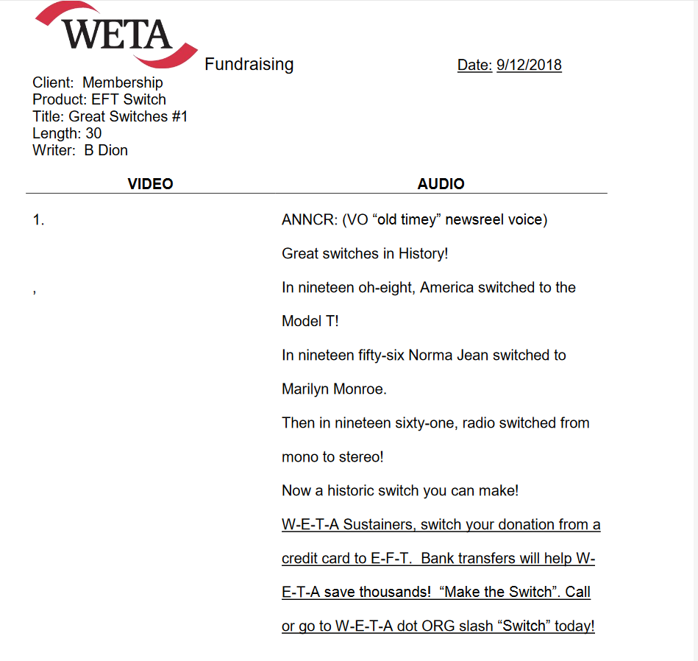

WETA TV Spot Copy

https://www.youtube.com/watch?v=K1JRq2LEDkM&feature=em-share_video_user

WETA TV Spot Copy

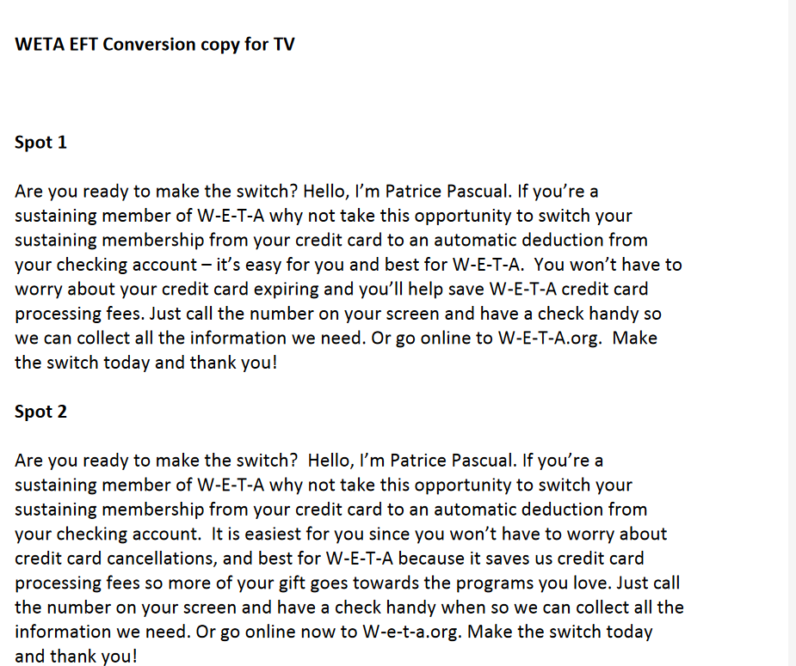

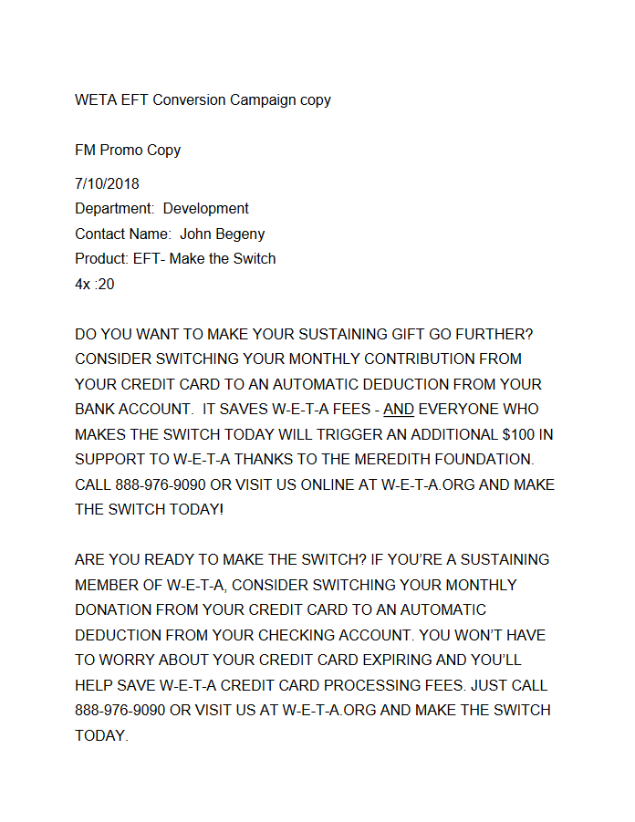

Classical WETA 90.9 FM Spots